Week Ending: | DAY: |  |  |  | Subject: Mathematics
Duration: 60mins per lesson |  |  |  |  | Strand: Geometry & Measurement
Class: B5 | Class Size: |  |  |  | Sub Strand: Data Collection & Organization
Content Standard:  B5.4.1.2 Construct and interpret double bar graphs to draw conclusions |  |  | Indicator:  B5.4.1.2.1-2 draw double bar graphs |  |  | Lesson:  1 OF 1
Performance Indicator:  - Learners can draw double bar graphs. |  |  |  | Core Competencies:  Problem Solving skills; Critical Thinking; Justification of Ideas;
Teaching/ Learning Resources |  | Class registers, school based assessment
References: Mathematics Curriculum Pg. 107-108
DAYS | PHASE 1: STARTER | PHASE 2: MAIN | PHASE 3: REFLECTION
Monday | Learners must count in reverse, numbers in a range continuously without breaking.  For example from (20 – 1).  Divide the class into groups. One person from each group countdown the range without breaking.  The group with the highest score wins! | Give students data presented in a table about the tallest tree of each species in the Ghana.  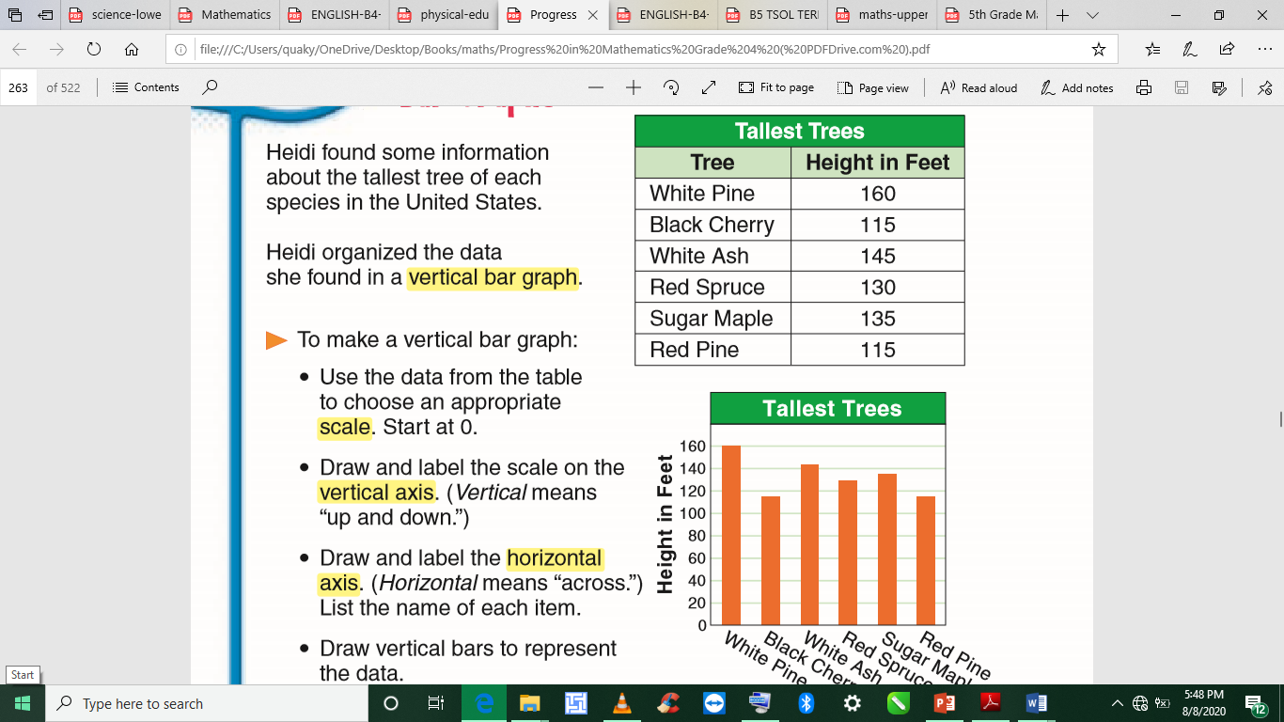 | Give learners task to complete whiles you go round to guide those who don’t understand.  Give remedial learning to those who may need special help.
Tuesday | Engage learners to solve this brain teaser  A farmer has 19 sheep on his land. One day, a big storm hits and all but seven run away. How many sheep does the farmer have left?  Answer: 7 | Give students data presented in a table on rainfall in mm for two towns to draw a double bar graph complete with title, labelled axes, key.  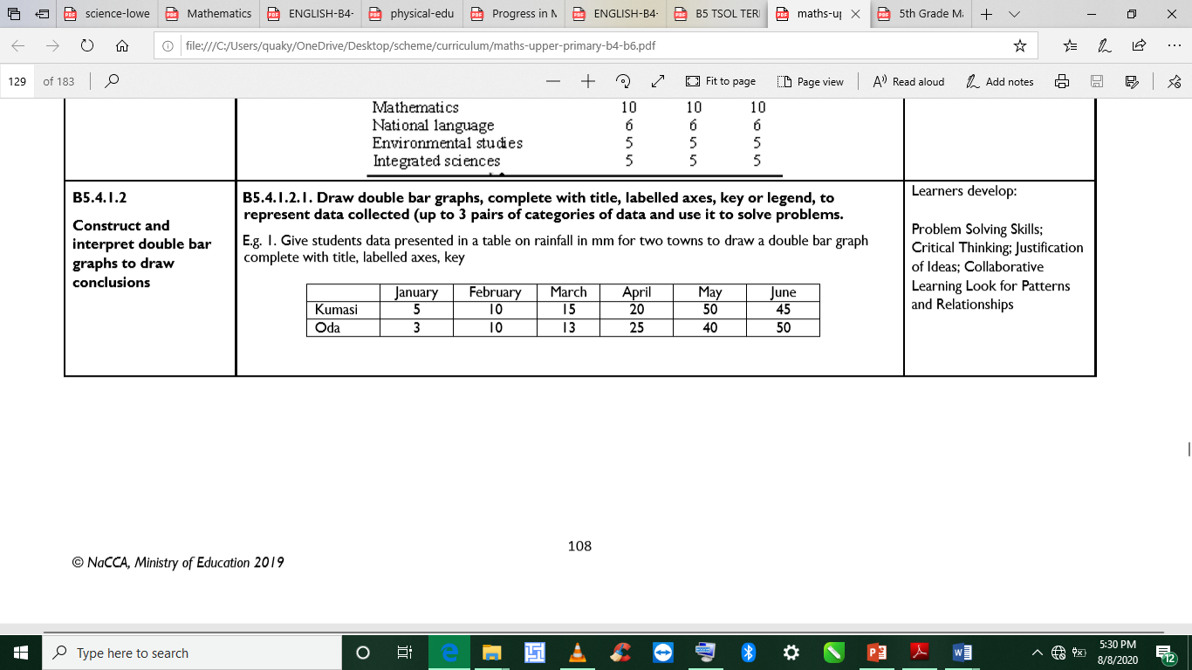  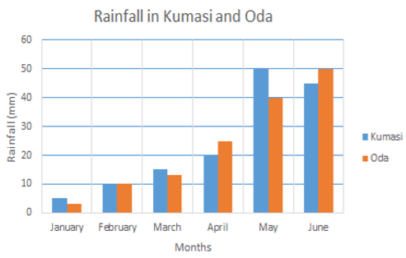 | Give learners task to complete whiles you go round to guide those who don’t understand.  Give remedial learning to those who may need special help.
Wednesday | Engage learners to sing the song  WE CAN COUNT  We class five  We can count  We count 1,2,3,4,5  We count 6,7,8,9,10  We class five can count very well. | Give students more paired data presented in tables.  Ask them to study the paired data in the tables and ask them questions based on them. Also ask them to write questions for their friends to read and interpret the data. For instance some questions can be  (i) In which subject was Fusena’s worse performance?  (ii) How many pupils are in the upper primary classes in Presby?  (iii) When was the best day for Senasco shop? | Give learners task to complete whiles you go round to guide those who don’t understand.  Give remedial learning to those who may need special help.
Thursday | Engage learners to solve this number pattern  If: 2+2=44  3+3=96  4+4=168  5+5=2510  Then: 6+6=?  Answer: 3612 | Ask learners to draw double bar graphs complete with title, labelled axes, key for the paired data presented in the tables on  (i) percentage test scores of 2 students;  (ii) enrolment in 2 schools in a town; sales of two of bread in two shops in a week; etc. used in a variety of print and electronic media, such as newspapers, magazines, and the internet. | Give learners task to complete whiles you go round to guide those who don’t understand.  Give remedial learning to those who may need special help.
Friday | Tell learners a few jokes to get their attention.  Call two learners to share their jokes as well | Provide opportunities for learners to access, read and interpret examples of double bar graphs used in a variety of print and electronic media, such as newspapers, magazines and the internet | Give learners task to complete whiles you go round to guide those who don’t understand.  Give remedial learning to those who may need special help.  Next lesson: Design and conduct an experiment in which the likelihood of a single outcome occurring is impossible, possible (likely or unlikely), certain

